**APSARA SIDDIQUI**

**RESTAURANT MANAGEMENT SYSTEM**

***“KIMCHI AND KPOP”***

**INTRODUCTION:**

This website offers Korean food to users.The front end is on jsp. The software we used is eclipse and the backend is on MySQL Workbench where all the concepts we studied about databases are implemented.

It mainly contains users and an admin panel.User will sign up if they doesn’t have an account,then they will choose dishes of their choice , will view their bill and can also able to give feedback and can state their opinion.Admin have his admin panel where he can view inventory, update the status of order,sales report, view customer list and order list.Admin can able to insert new item and have access to delete a user who doesn’t engaged with the website more than a month.

**NORMALIZATION:**

**Restaurant DataBase:**

Restaurant(Restraunt_id, Restraunt_Name, Location, Restaurant_Phone,Customer_id,Manager_id)

Customer(Customer_id,Customer_Fname,Customer_Lname,Customer_Phone,Customer_Address, Order_id, Menu_id)

Manager(Manager_id, Manager_Name, Manager_Phone, Salary, Customer_id, Menu_id)

Rider(Rider_id, Rider_Name, Rider_Phone, Rider_Salary, Order_id,Customer_id,Restraunt_id)

Order(Order_id,items,Amount,Customer_id,Restraunt_id)

Menu(Menu_id, deals, Item, Prices, Description, Restraunt_id )

Bill(Bill_id,Total_Amount,COD,Order_id, Customer_id)

**Description:**

Restaurant

PK:Restraunt_id

Customer

PK:Customer_id

FK:Order_id, Menu_id, Restaurant_id

Manager

PK:Manager_id

FK:Customer_id, Menu_id, Restaurant_id

Rider

PK:Rider_id

FK:Order_id,Customer_id,Restraunt_id

Order

PK:Order_id

FK:Customer_id,Restraunt_id

Menu

PK:Menu_id,

FK:Restraunt_id

Bill

PK:Bill_id

FK:Order_id, Customer_id

1. **Relation: Customer Places Order**

| Customer_id | Customer_FName | Customer_LName | Customer_Address | Customer_Phone | Order_id | Items | Amount | Menu_id | Restraunt_id |
| --- | --- | --- | --- | --- | --- | --- | --- | --- | --- |

* We simply show the normalization between Customer and Order attributes, without specifying their foreign keys.

**1NF:**

| Customer_id | Customer_FName | Customer_LName | Customer_Address | Customer_Phone | Order_id | Items | Amount |
| --- | --- | --- | --- | --- | --- | --- | --- |

**FD1:**

Customer_id, Order_id→Cusomer_Fname,Cusomer_Lname,Customer_Phone,Customer_Address,items,Amount

**FD2:**

Customer_id→Cusomer_Fname,Cusomer_Lname,Customer_Phone,Customer_Address

**FD3:**

Order_id→items

**FD4:**

Customer_id, Order_id→Amount

**FD5:**

**2NF(Partial Dependencies):**

| Customer_id | Customer_FName | Customer_LName | Customer_Address | Customer_Phone |
| --- | --- | --- | --- | --- |

| Restraunt_id | Restraunt_Name | Location | Restaurant_Phone |
| --- | --- | --- | --- |

| Customer_id | Order_id | Restraunt_id | Amount |
| --- | --- | --- | --- |

| Order_id | Items |
| --- | --- |

**3NF:**

**No Transitive Dependencies.**

| Customer_id | Customer_FName | Customer_LName | Customer_Address | Customer_Phone |
| --- | --- | --- | --- | --- |

| Restraunt_id | Restraunt_Name | Location | Restaurant_Phone |
| --- | --- | --- | --- |

| Customer_id | Order_id | Amount |
| --- | --- | --- |

| Order_id | Items |
| --- | --- |

1. **Relation: Customer Browses Menu**

| Customer_id | Customer_FName | Customer_LName | Customer_Address | Customer_Phone | Menu_id | Item | Prices | Description | Deals | Order_id | Restraunt_id |
| --- | --- | --- | --- | --- | --- | --- | --- | --- | --- | --- | --- |

* We simply show the normalization between Customer and Menu attributes, without specifying their foreign keys.

**1NF:**

| Customer_id | Customer_FName | Customer_LName | Customer_Address | Customer_Phone | Menu_id | Item | Prices | Description | Deals |
| --- | --- | --- | --- | --- | --- | --- | --- | --- | --- |

**FD1:**

Customer_id , Menu_id→Customer_FName,Customer_LName,Customer_Address,Customer_Phone,Item,Prices,Description,Deals

**FD2:**

Customer_id →Customer_FName,Customer_LName,Customer_Address,Customer_Phone

**FD3:**

Menu_id →Item,Prices,Description

**FD4:**

Customer_id , Menu_id → Deals

**2NF(Partial Dependencies):**

| Customer_id | Customer_FName | Customer_LName | Customer_Address | Customer_Phone |
| --- | --- | --- | --- | --- |

| Menu_id | Prices | Description | Item |
| --- | --- | --- | --- |

| Menu_id | Customer_id | Deals |
| --- | --- | --- |

**3NF:**

**No Transitive Dependencies.**

| Customer_id | Customer_FName | Customer_LName | Customer_Address | Customer_Phone |
| --- | --- | --- | --- | --- |

| Menu_id | Prices | Description | Item |
| --- | --- | --- | --- |

| Menu_id | Restaurant_id | Deals |
| --- | --- | --- |

1. **Relation: Customer Pays Bill**

| Customer_id | Customer_FName | Customer_LName | Customer_Address | Customer_Phone | Bill_id | Total_Amount | COD | Order_id | Menu_id |
| --- | --- | --- | --- | --- | --- | --- | --- | --- | --- |

* We simply show the normalization between Customer and Bill attributes, without specifying their foreign keys.

**1NF:**

| Customer_id | Customer_FName | Customer_LName | Customer_Address | Customer_Phone | Bill_id | Total_Amount | COD |
| --- | --- | --- | --- | --- | --- | --- | --- |

**FD1:**

Customer_id , Bill_id , Order_id→Customer_FName,Customer_LName,Customer_Address,Customer_Phone,Total_Amount,COD

**FD2:**

Customer_id →Customer_FName,Customer_LName,Customer_Address,Customer_Phone

**FD3:**

Bill_id → COD

**FD4:**

Customer_id ,Bill_id →Total_Amount

**2NF(Partial Dependencies):**

| Customer_id | Customer_FName | Customer_LName | Customer_Address | Customer_Phone |
| --- | --- | --- | --- | --- |

| Bill_id | COD |
| --- | --- |

| Customer_id | Bill_id | Total_Amount |
| --- | --- | --- |

**3NF:**

**No Transitive Dependencies.**

| Customer_id | Customer_FName | Customer_LName | Customer_Address | Customer_Phone |
| --- | --- | --- | --- | --- |

| Bill_id | COD |
| --- | --- |

| Customer_id | Bill_id | Total_Amount |
| --- | --- | --- |

1. **Relation: Restaurant Receives Order**

| Restaurant_id | Restaurant_Name | Location | Resaurant_Phone | Order_id | Items | Amount | Customer_id | Manager_id |
| --- | --- | --- | --- | --- | --- | --- | --- | --- |

* We simply show the normalization between Restaurant and Order attributes, without specifying their foreign keys.

**1NF:**

| Restaurant_id | Restaurant_Name | Location | Resaurant_Phone | Order_id | Items | Amount |
| --- | --- | --- | --- | --- | --- | --- |

**FD1:**

Restaurant_id, Order_id→Restaurant_Name, Location, Restaurant_Phone, Items, Amount

**FD2:**

Restaurant_id→Restaurant_Name, Location, Restaurant_Phone

**FD3:**

Restaurant_id, Order_id→Amount

**FD4:**

Order_id→Item

**2NF(Partial Dependencies):**

| Restaurant_id | Restaurant_Name | Location | Resaurant_Phone |
| --- | --- | --- | --- |

| Restaurant_id | Order_id | Amount |
| --- | --- | --- |

| Order_id | Items |
| --- | --- |

**3NF:**

**No Transitive Dependencies.**

| Restaurant_id | Restaurant_Name | Location | Resaurant_Phone |
| --- | --- | --- | --- |

| Restaurant_id | Order_id | Amount |
| --- | --- | --- |

| Order_id | Items |
| --- | --- |

1. **Relation: Rider Delivers Order**

| Rider_id | Rider_Name | Rider_Phone | Rider_Salary | Order_id | Items | Amount | Menu_id | Restraunt_id | Customer_Id |
| --- | --- | --- | --- | --- | --- | --- | --- | --- | --- |

* We simply show the normalization between Rider and Order attributes, without specifying their foreign keys.

**1NF:**

| Rider_id | Rider_Name | Rider_Phone | Rider_Salary | Order_id | Items | Amount |
| --- | --- | --- | --- | --- | --- | --- |

**FD1:**

Rider_id, Order_id→Rider_Name,Rider_Phone,Rider_Salary, Items, Amount

**FD2:**

Rider_id→Rider_Name,Rider_Phone

**FD3:**

Rider_id,Order_id→Amount, Rider_Salary

**FD4:**

Order_id→Item

**2NF(Partial Dependencies):**

| Rider_id | Rider_Name | Rider_Phone |
| --- | --- | --- |

| Rider_id | Order_id | Amount | Rider_Salary |
| --- | --- | --- | --- |

| Order_id | Items |
| --- | --- |

**3NF:**

**No Transitive Dependencies.**

| Rider_id | Rider_Name | Rider_Phone |
| --- | --- | --- |

| Rider_id | Order_id | Amount | Rider_Salary |
| --- | --- | --- | --- |

| Order_id | Items |
| --- | --- |

1. **Relation: Manager Updates Menu**

| Manager_id | Manager_Name | Manager_Phone | Salary | Customer_id | Menu_id | deals | Item | Prices | Description | Restraunt_id |
| --- | --- | --- | --- | --- | --- | --- | --- | --- | --- | --- |

* We simply show the normalization between Manager and Menu attributes, without specifying their foreign keys.

**1NF:**

| Manager_id | Manager_Name | Manager_Phone | Salary | Menu_id | deals | Item | Prices | Description |
| --- | --- | --- | --- | --- | --- | --- | --- | --- |

**FD1:**

Manager_id,Menu_id→Manager_Name,Manager_Phone,Salary,deals,Item,Prices,Description

**FD2:**

Manager_id→Manager_Name,Manager_Phone,Salary

**FD3:**

Menu_id→Item,Prices

**FD4:**

Manager_id,Menu_id→deals

**2NF(Partial Dependencies):**

| Manager_id | Manager_Name | Manager_Phone | Salary |
| --- | --- | --- | --- |

| Menu_id | Item | Prices |
| --- | --- | --- |

| Manager_id | Menu_id | deals |
| --- | --- | --- |

**3NF:**

**No Transitive Dependencies.**

| Manager_id | Manager_Name | Manager_Phone | Salary |
| --- | --- | --- | --- |

| Menu_id | Item | Prices |
| --- | --- | --- |

| Manager_id | Menu_id | deals |
| --- | --- | --- |

1. **Relation: Manager manages Restaurant**

| Manager_id | Manager_Name | Manager_Phone | Salary | Restaurant_id | Resaurant_Name | Location | Resaurant_Phone | Manager_id | Customer_id |
| --- | --- | --- | --- | --- | --- | --- | --- | --- | --- |

* We simply show the normalization between Manager and Restaurant attributes, without specifying their foreign keys.

**1NF:**

| Manager_id | Manager_Name | Manager_Phone | Salary | Restaurant_id | Resaurant_Name | Location | Resaurant_Phone |
| --- | --- | --- | --- | --- | --- | --- | --- |

**FD1:**

Manager_id,Restaurant_id→Manager_Name,Manager_Phone,Salary,Resaurant_Name,Location,Resaurant_Phone

**FD2:**

Manager_id→Manager_Name,Manager_Phone,Salary

**FD3:**

Restaurant_id→Resaurant_Name,Location,Resaurant_Phone

**2NF(Partial Dependencies):**

| Manager_id | Manager_Name | Manager_Phone | Salary |
| --- | --- | --- | --- |

| Restaurant_id | Restaurant_Name | Location | Resaurant_Phone |
| --- | --- | --- | --- |

**3NF:**

**No Transitive Dependencies.**

| Manager_id | Manager_Name | Manager_Phone | Salary |
| --- | --- | --- | --- |

| Restaurant_id | Restaurant_Name | Location | Resaurant_Phone |
| --- | --- | --- | --- |

**Entity Relationship Diagram:**

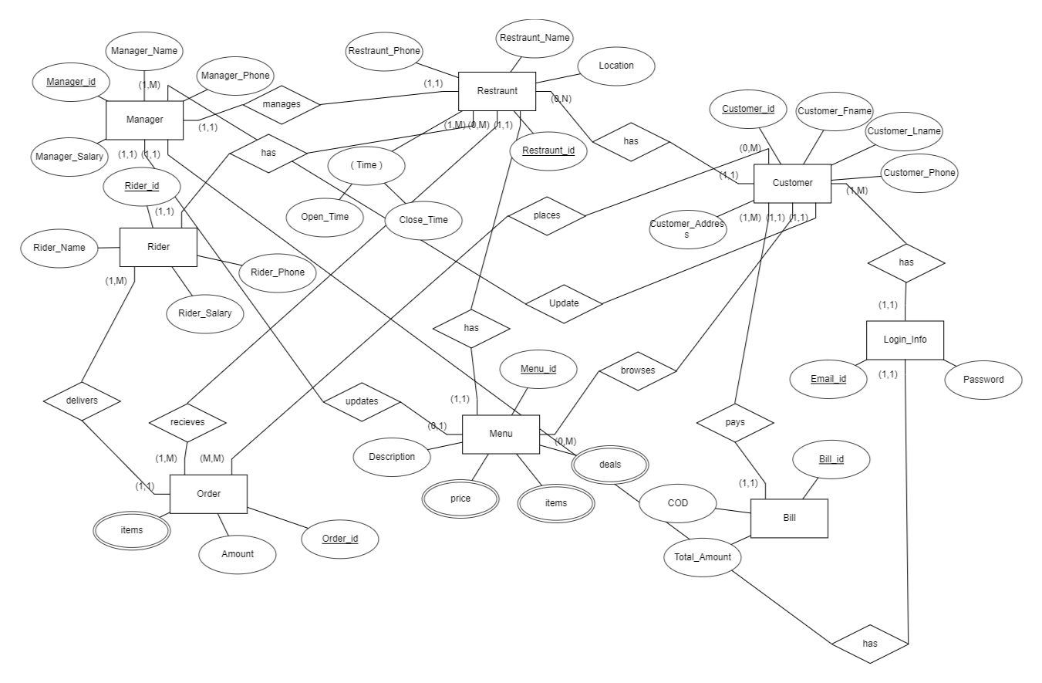

**Features And Screenshots:**

**Website:**

**User Login:**

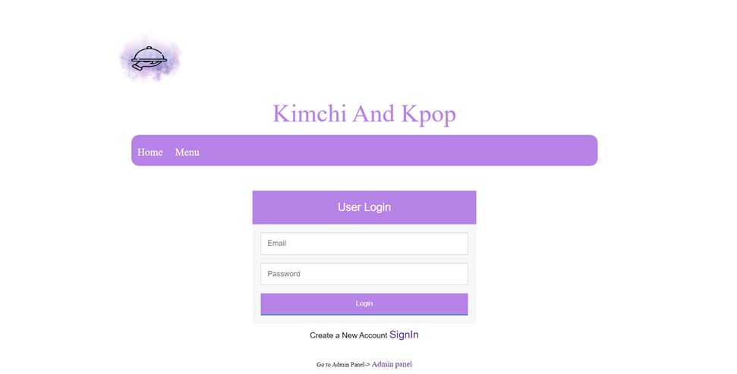

**Home page After successful Login else sign In**

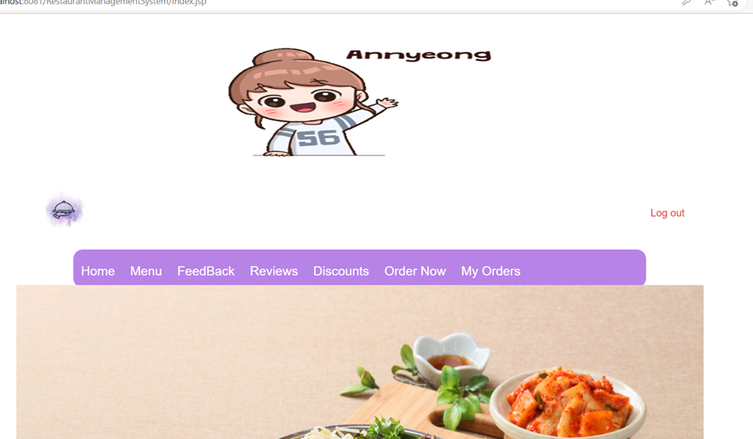

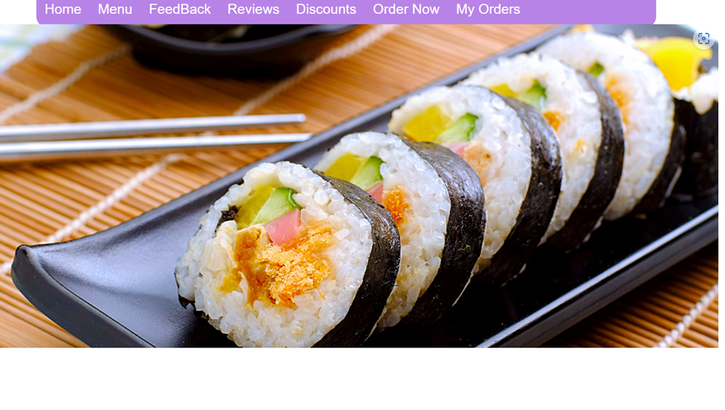

**After Clicking On Menu:**

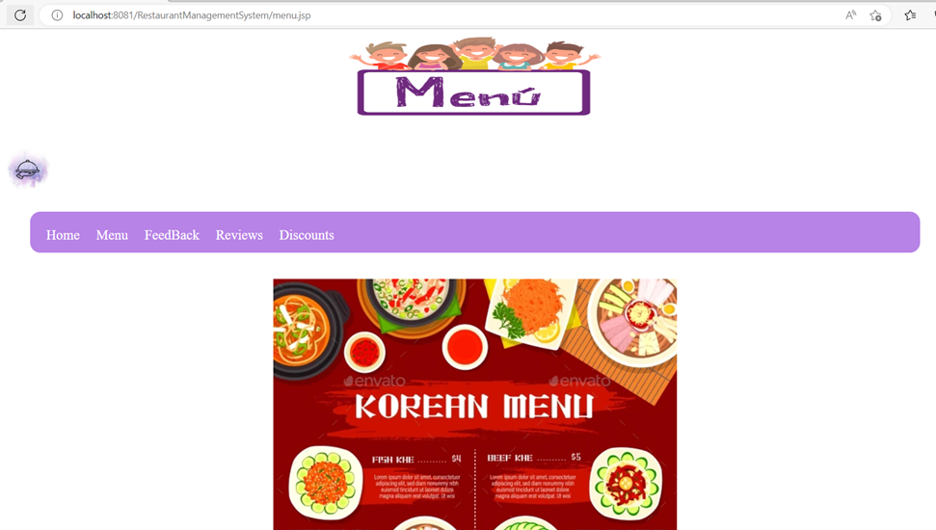

**Order Now:**

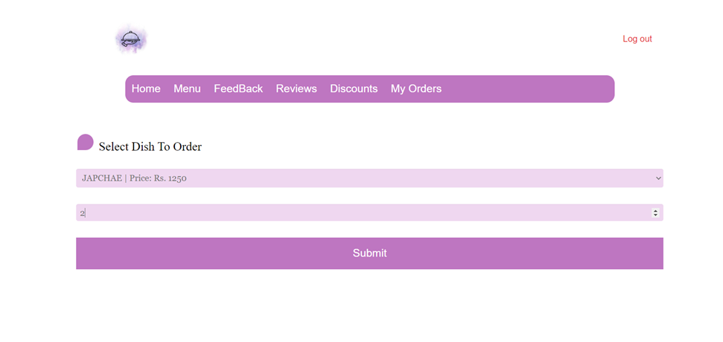

**After Submitting Confirm Your Order:**

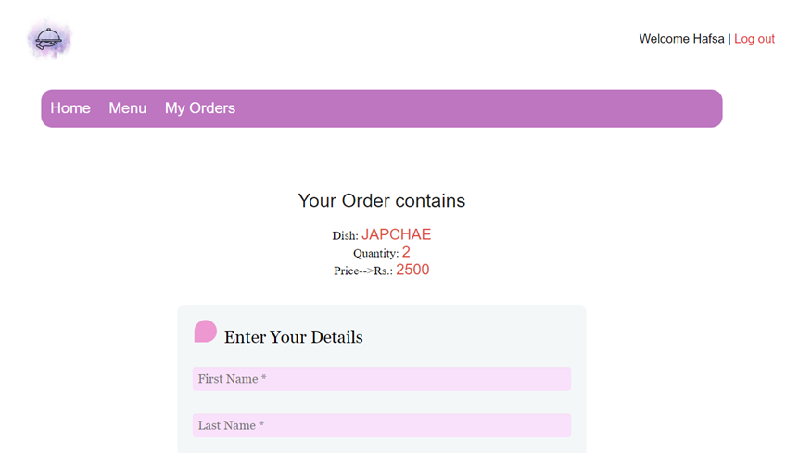

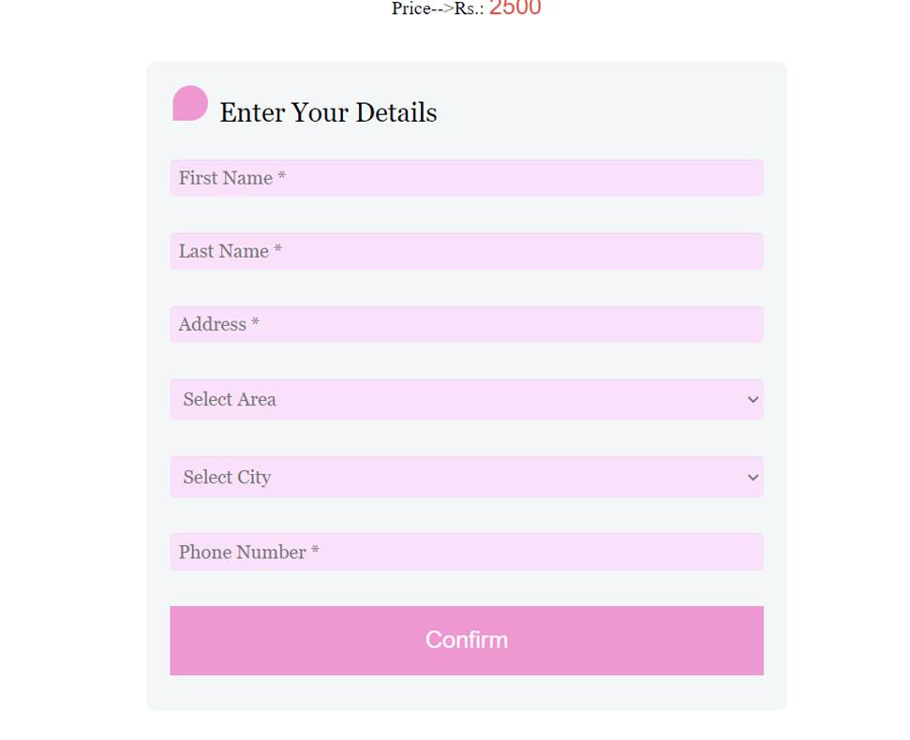

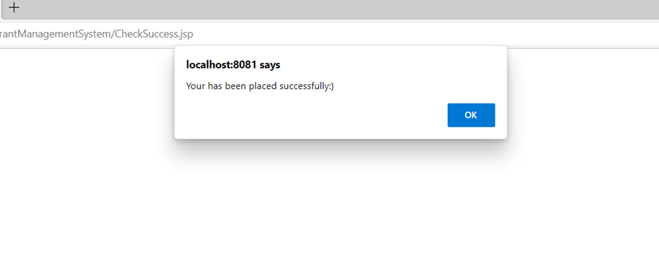

**Give Your Feedback:**

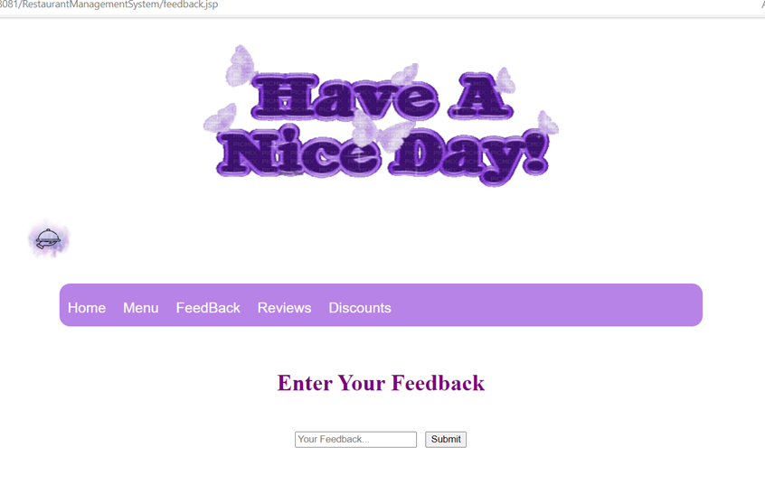

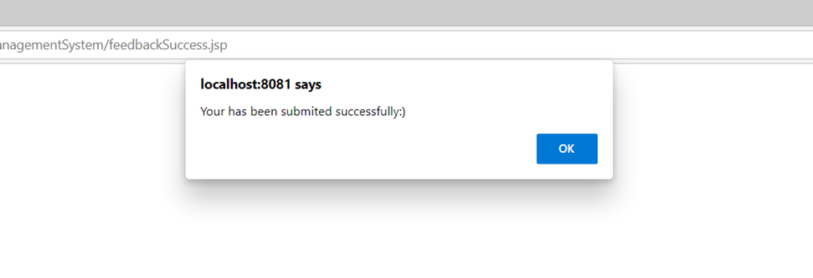

**Logout:**

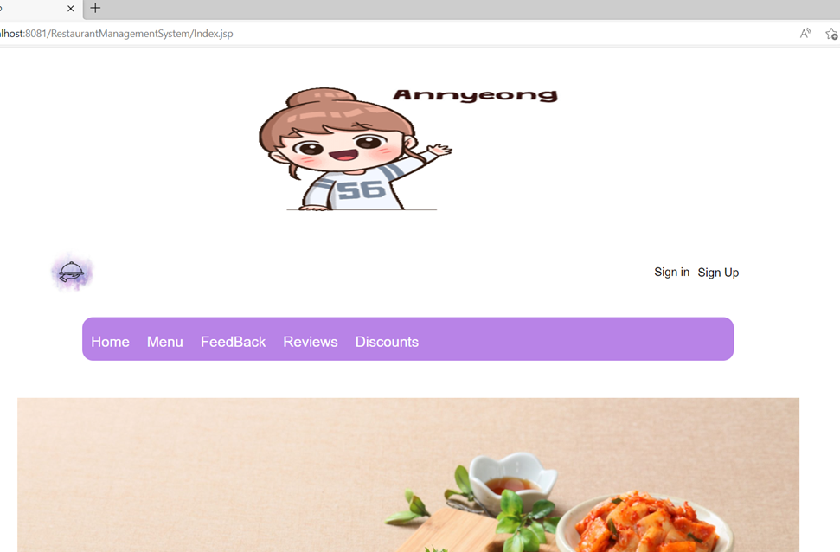

**Admin Login:**

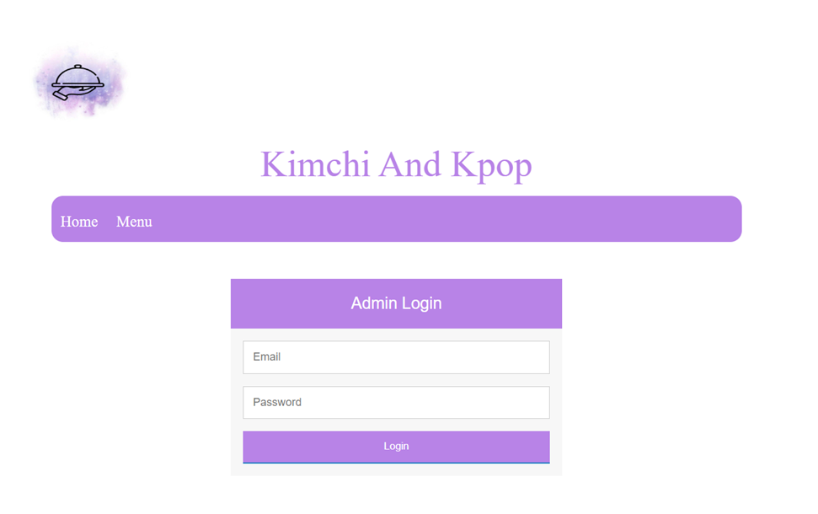

**All Options:**

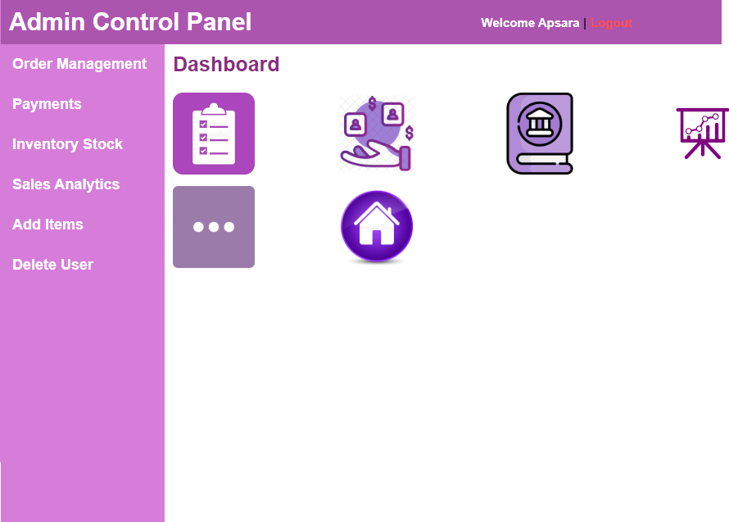

**All DashBoard Options:**



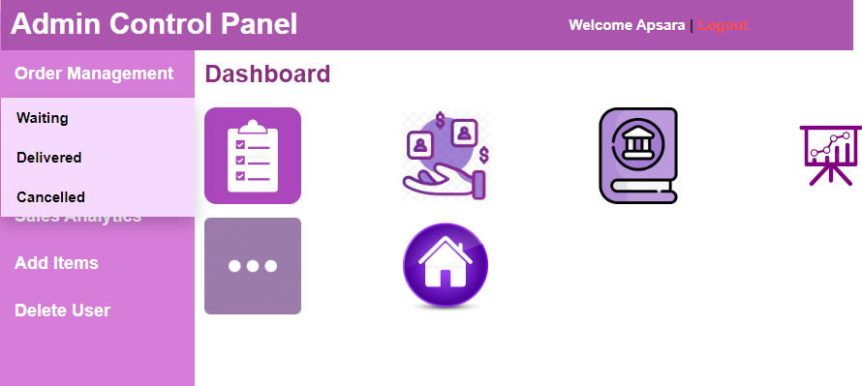

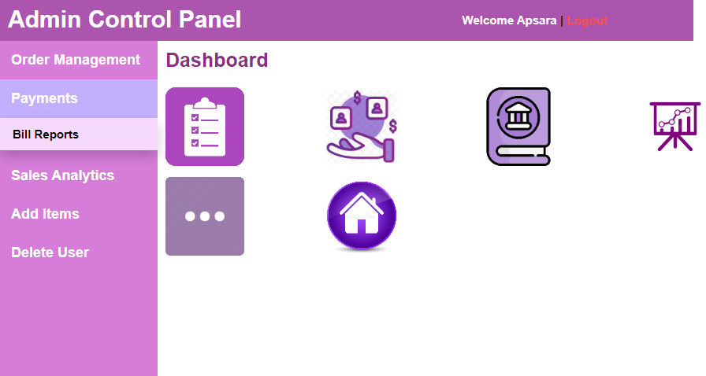

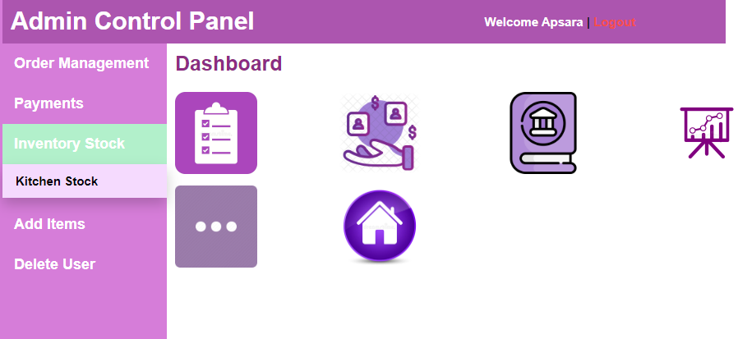

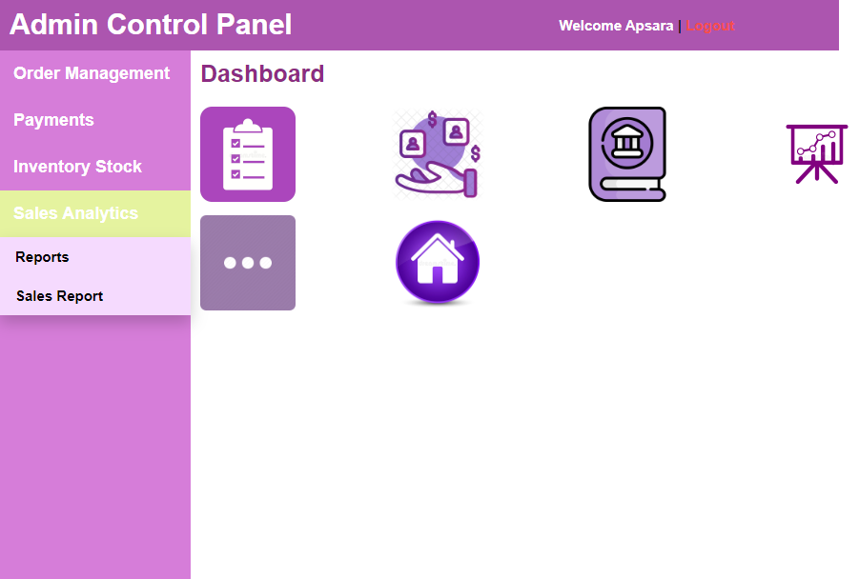

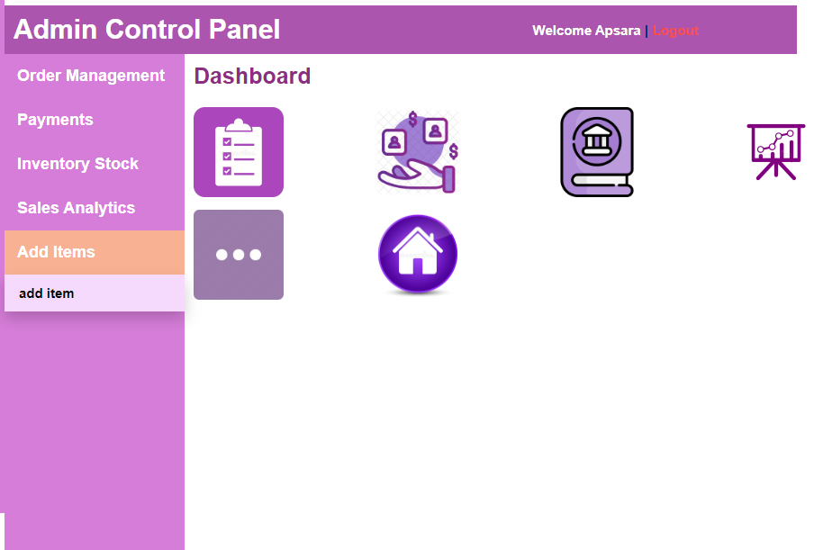

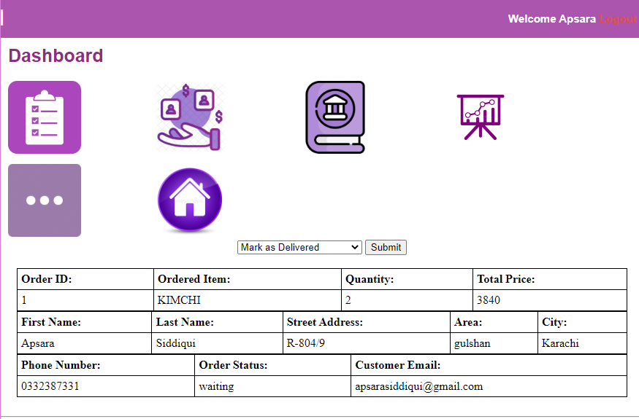

* Admin can view customer details

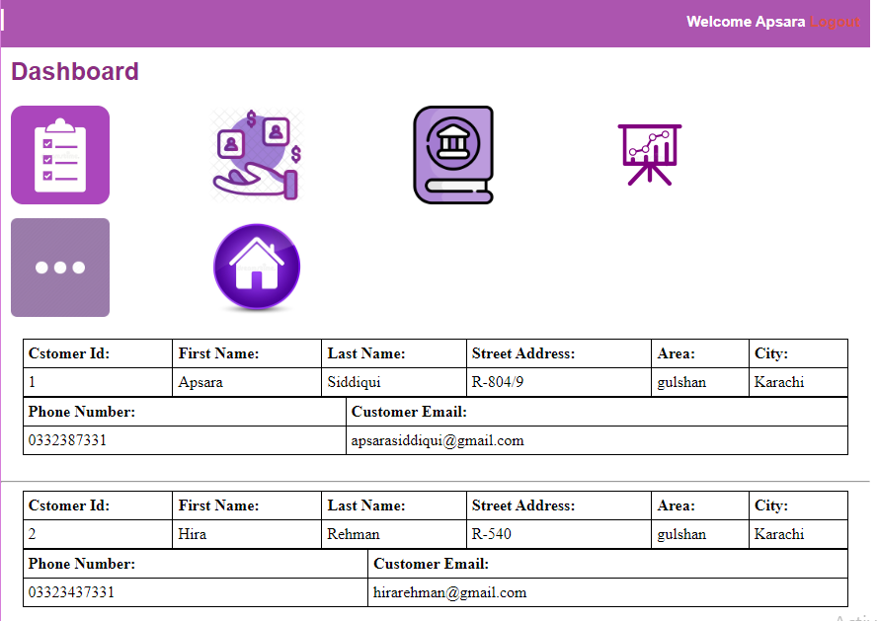

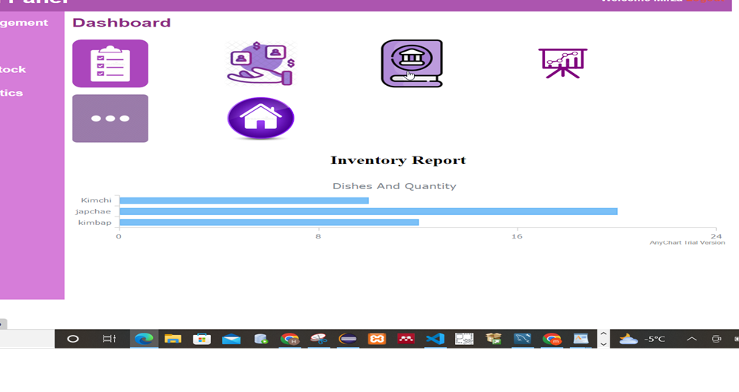

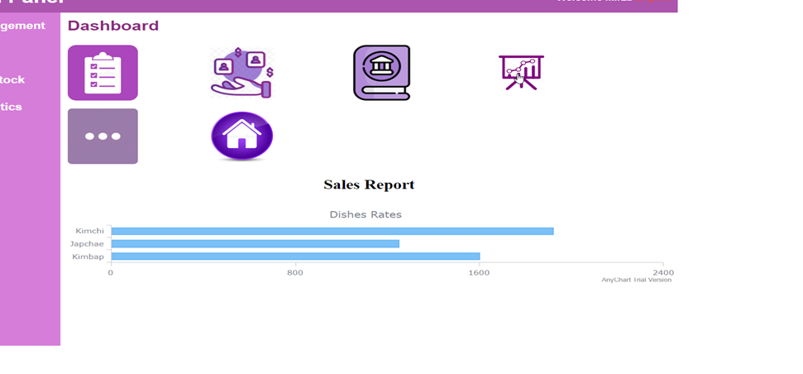

**Go to homepage:**



**Reviews:**

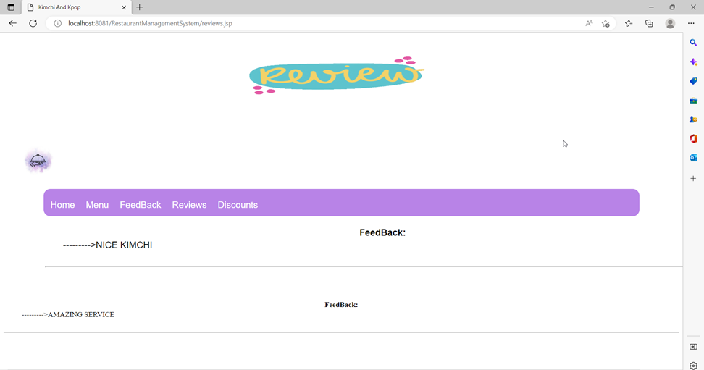

**Discounts:**

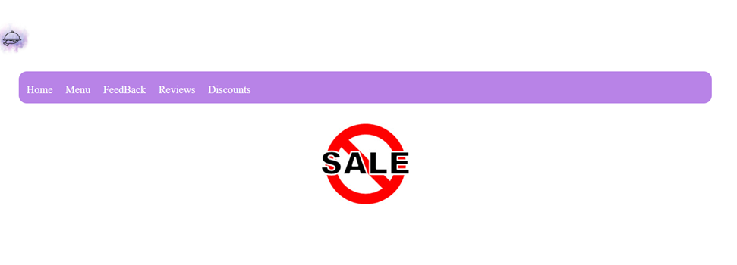

**Admin Update Billing Status:**



* Update order status to delivered



* order status updated to delivered from waiting

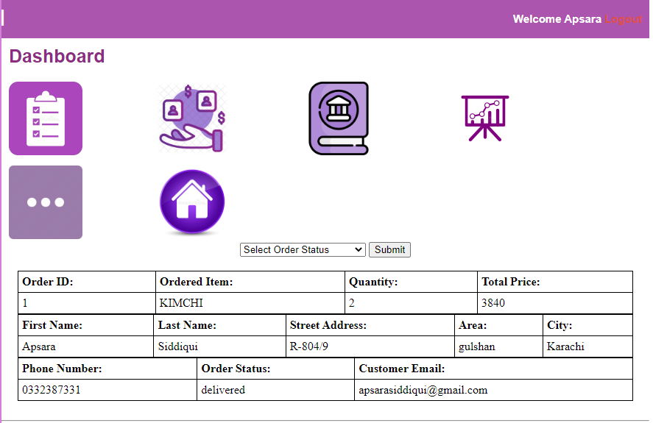

**Admin Add Item:**

* Admin can add new item(i.e noodles)

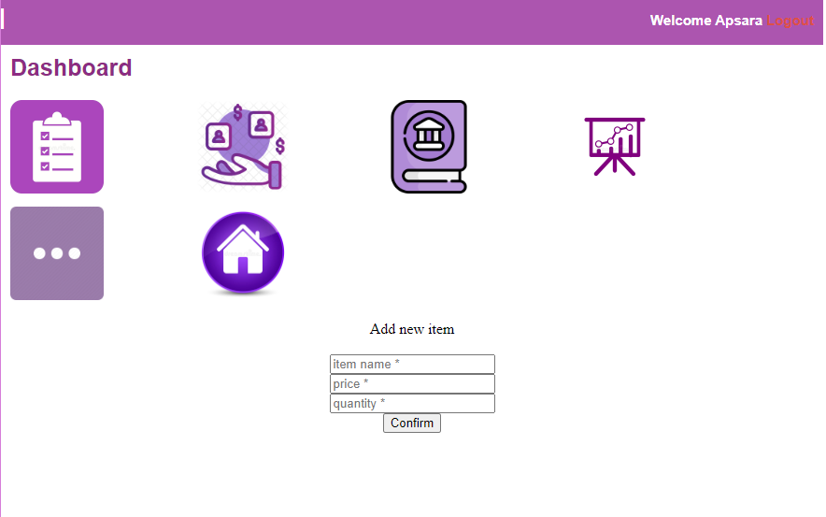

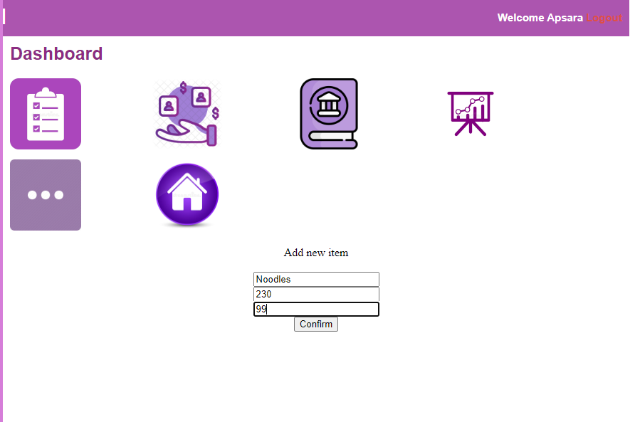



* User can now order noodles as its showing in dropdown menu

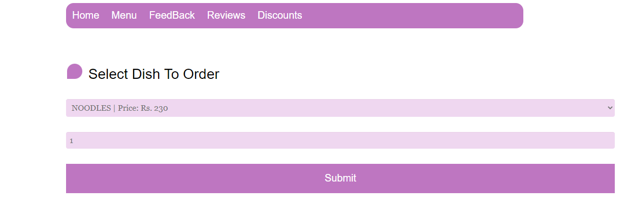

**Admin Delete User:**

* Admin can delete user by entering their user id

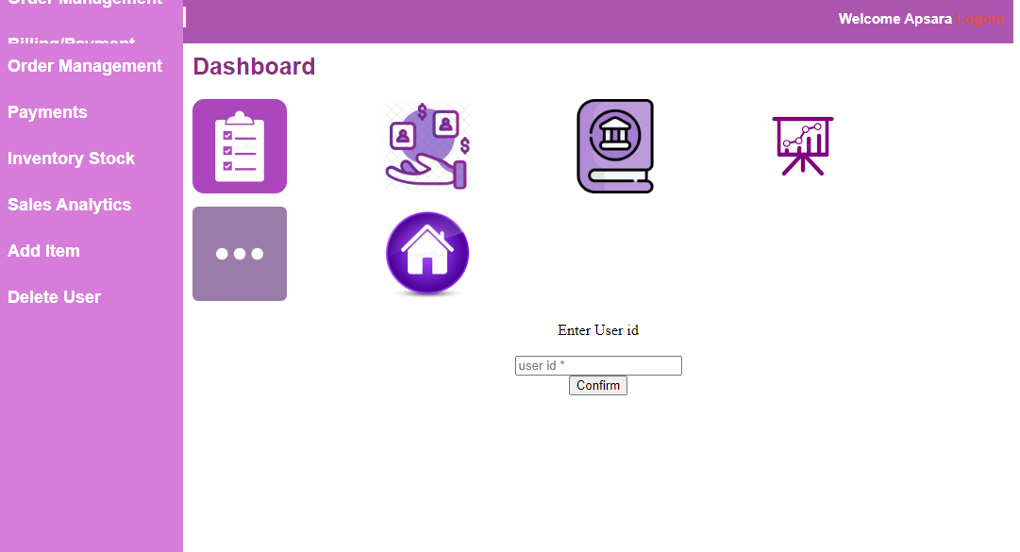

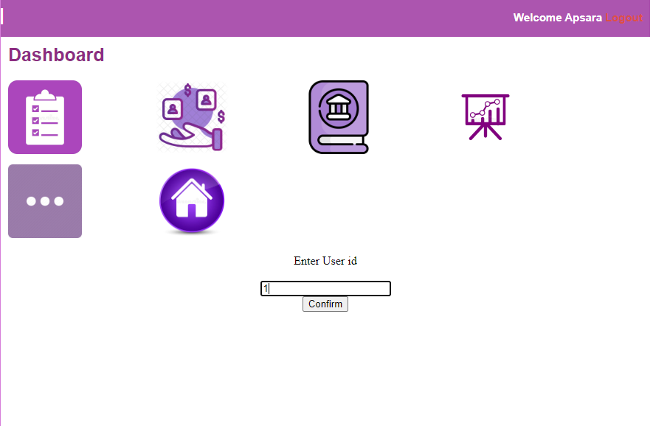

* Admin can view customer details
* Before deleting details



* After deleting details customer view

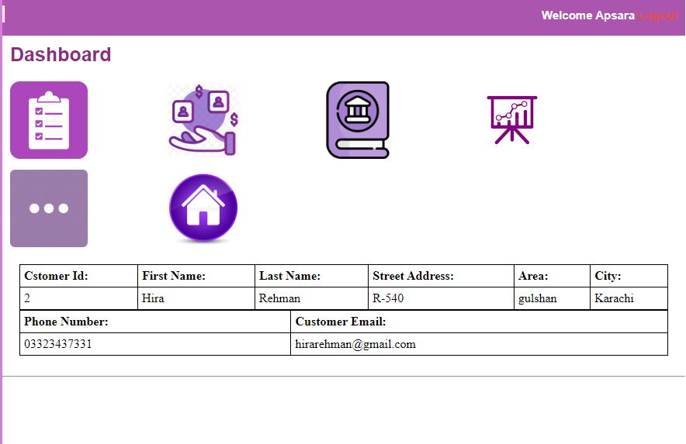

**Database:**

* A brief view of the database with tables,alert(pk),transactions,triggers.

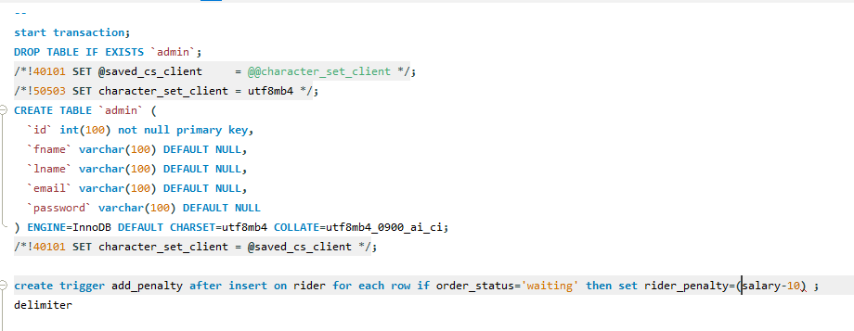

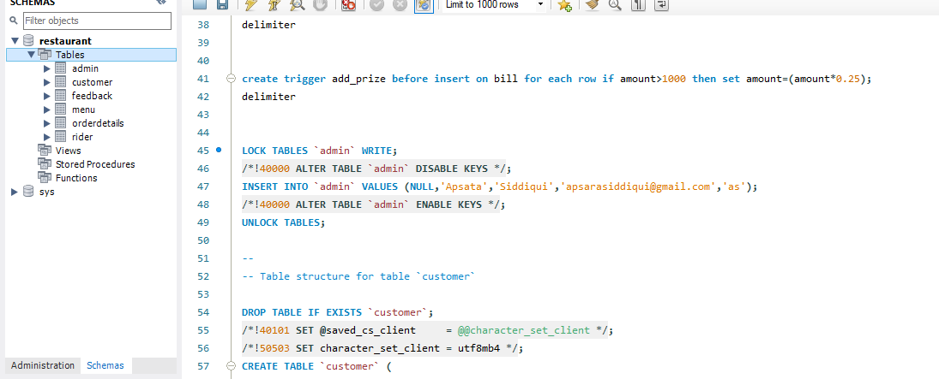

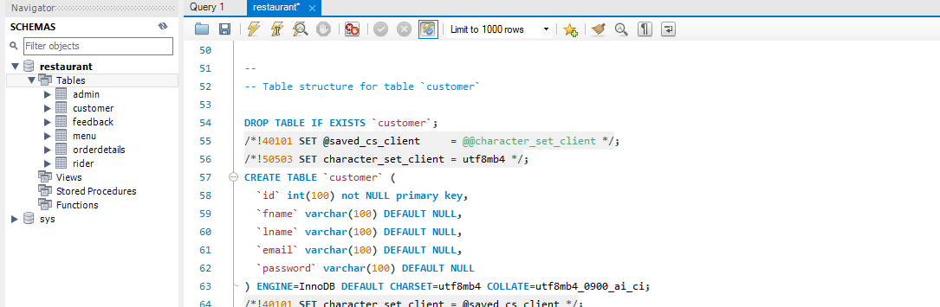

* Before encryption

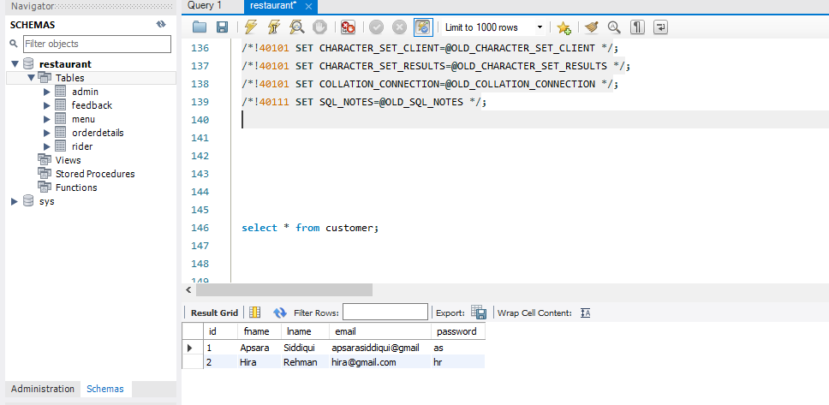

* After encryption

